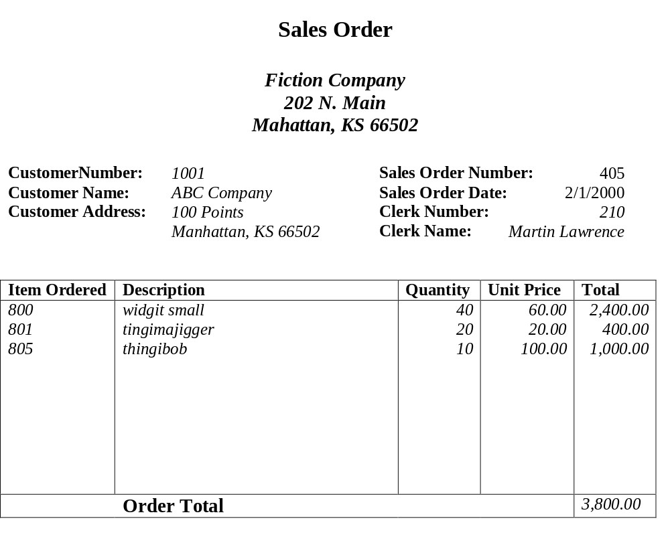
Example1:

Primary Key: Sales Order Number,

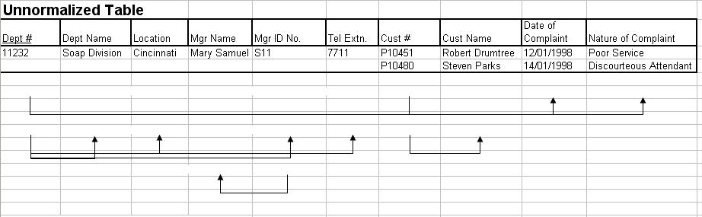
Example2:

